Minutes of the General Meeting of the Comstock Grizzlies
Saturday May 17th @ 6:30 PM
Nathan and Ken’s Home – Sparks, NV

General information and attendance:

Meeting called to order @ 7:05 PM by President Ken

Meeting Attendee’s:
Nathan, Ken, Dan, Tom, Jason, Thomas, Mike
Tat, Steve, Max, Dean, Kyle, Anthony, Tim, Abe

Attendee’s: 15

April 2025 minutes were sent to group.

Motion to approve as sent.
Motion: Max Second Thomas Approved by acclimation.

Current information for these minutes.
Treasurers Report: Through 05/15/2025

Previous Balance: $ 530.46
Transactions: IN $ 00.00
Ending Balance: $ 530.46
Net Change: $ + 00.00
NO CHANGE

Motion to approve the Treasury Report.
Motion: Max Second Thomas Approved by acclimation.

Although dues are not required to attend activities.
We are all encouraged to renew your dues
and look at friends to become members.
Just so we have funds for our club expenses.

Web/Facebook Report:
FULLY UPDATED

Old Business:

Several Suggestions were made for our Spring / Summer
Activities. Details to be attached and discussed at the next
Meeting.

Summer Outing Information I provided was discussed.
I (Nathan) explained some information I researched for each. Do to scheduling, logistics or cost not all suggestions may be scheduled.

I am putting a calendar together that will be sent out
in a separate email. Please use it for planning. But be aware there could be changes as we go forward.

New Business:

None

Next Dinner Night Out (DNO) will be at:

We had multiple suggestions for DNO
So I have listed one for June, July and August

June 2025

Miguel's Mexican Food At Midtown
1415 S Virginia St, Reno, NV 89502
Wednesday June 4th @ 6:30pm
Mike to make reservation.

July 2025

Boulevard Pizza
1076 Rock Blvd #105, Sparks, NV 89431
Wenesday July 9th @ 6:30pm
Max to make reservation, if needed.

August 2025

Black Bear Diner
2323 South Virginia Street Reno, NV 89502
Wenesdau August 6th @ 6:30pm
Abe to make reservation.

Nathan made a suggestion to the group to please
bring cash in case a restaurant does not allow separate checks. We will still always ask if they can do it.
Thank you,

Pot Luck Dinner and Club Meeting – Typically the 3rd
Saturday of the month

There was a suggestion and discussion on having
a theme for our dinners. After discussing we decided
to give it a try. It is a meal suggestion, not a requirement.
Just have FUN with it. Feel free to bring what you wish.

Next Meetings:
We are also planning ahead for the next 4 meetings.
June, July, August, September 2025

June Meeting and Annual Beer Bust

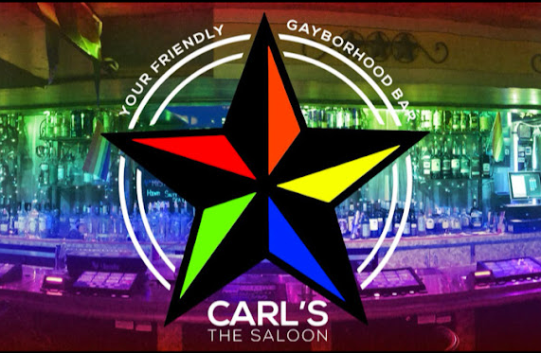

June 21st from 3pm – 6pm
Details to attached.
Meeting to follow Beer Bust

Group approved $100 for purchase of supplies for the Beer Bust.

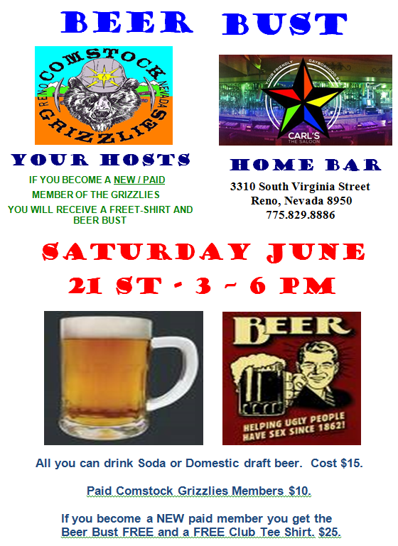

July Meeting and Pot Luck
Nathan and Ken’s Home Sparks
Saturday July 19th @ 6:30pm

Theme for this dinner is BBQ.
Ken and I will be providing
BBQ Chicken and Grilled burgers.
No need for main dishes unless you wish something for yourself.

Please bring side dished for a BBQ.

August Meeting and Pot Luck
Location TBD – Ken and I are out of town.
Saturday August 16th @ 6:30pm

No theme for this dinner.

September Meeting and Pot Luck
Nathan and Ken’s Home Sparks
Saturday September 20th @ 6:30pm

No theme for this dinner.

Hope to see you all there.

Close the meeting:
Motion: Max Second Thomas, Approved by acclimation.
Approved at 7:52 PM.

Respectfully Submitted
Nathan C. Secretary May 25, 2025
SPRING AND SUMMER PLANNING INFORMATION

POKER NIGHT WITH SNACKS (NO DINNER)
Hosted by Nathan and Ken.
Planned for Wed June 11 @ 6:30pm
Suggested $20 Buy-in.
Ken and I will be providing snacks.

ACES BASEBALL NIGHT

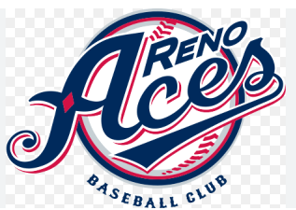
GREATER NEVADA FIELD

Thanks to Anthony we have been given 15 tickets for the
Aces Gay Pride Game. The game is planned for June 26 at 5:30pm.
You will need to reserve your ticket with me (Nathan) by June 23rd.
I will distribute the tickets at the game. Make sure you are going to make it before you text me at 775-690-5179 to hold a ticket for you.
Concessions are all cash less now. Game starts at 6:30 pm

GAME NIGHT AND ICE CREAM SOCIAL (NO DINNER)

Hosted by Nathan and Ken.
Planned for Wed July 16 @ 6:30pm
No need to bring anything.
I’ll be over doing it and we should have plenty.

MAGIC CARPET MINI GOLF

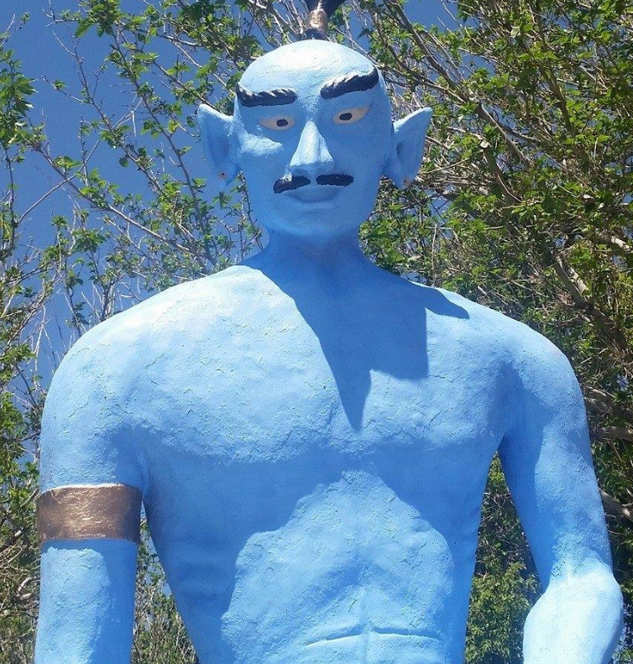
6925 S. VIRGINIA ST. RENO, NV 89511
COST $13 Cash $13.52 Card.
Planned for Wed July 23 @ 6:30pm

TRIP TO NEVADA MUSEUM OF ART

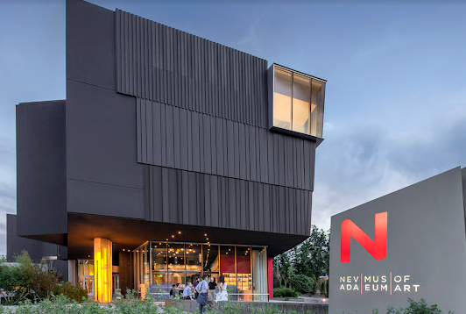

This outing would need to be on a Thursday and start earlier (5pm) do to their hours. Cost $15
I have asked Thomas to host this outing. Members will need to get with him to coordinate and confirm you are attending.
I have planned it for Thu Aug 14 @ 5pm due to their hours

TRIP TO RENO ANIMAL ARK

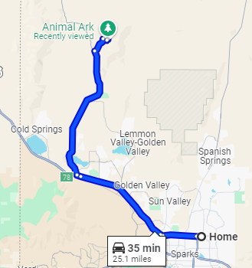
1265 Deerlodge Road. Reno, NV

This should be planned for a Saturday or Sunday.
Morning is best for viewing animals. Cost $20 / $16 Seniors.
Tickets only available online.
It is a 35 minute drive for our house so carpooling is suggested.
This will planned for Sunday Aug 24 @ 10:30am. Planning early start so it is not to hot and it is best time to see animals.
MONTH | DAY | DATE | TIME | NOTES
JUNE | WED | 4 | 6:30 | DNO MIGUELS
JUNE | WED | 11 | 6:30 | POKER NIGHT @ N&K
JUNE | SAT | 21 | 3 | MEETING AFTER BEER BUST @ CARLS
JUNE | THU | 26 | 5:30 | ACES GAME @ 6:30
JULY | WED | 9 | 6:30 | DNO BOULEVARD PIZZA
JULY | WED | 16 | 6:30 | GAME/ICE CREAM NIGHT @ N&K
JULY | SAT | 19 | 6:30 | MEETING BBQ @ N&K
JULY | WED | 23 | 6:30 | MAGIC CARPET MINI GOLF
AUGUST | WED | 6 | 6:30 | DNO BLACK BEAR DINER
AUGUST | THU | 14 | 0:00 | NEV MUSEUM HOST THOMAS
AUGUST | SAT | 16 | 6:30 | TBD
AUGUST | SUN | 24 | 10:00 | ANIMAL ARC - CAR POOLING
SEPTEMBER | SAT | 20 | 6:30 | MEETING POT LUCK @ N&K

EVERYTHING IS PLANNED BUT COULD CHANGE IN THE FUTURE.

Not scheduled at this time

BOWLING NIGHT
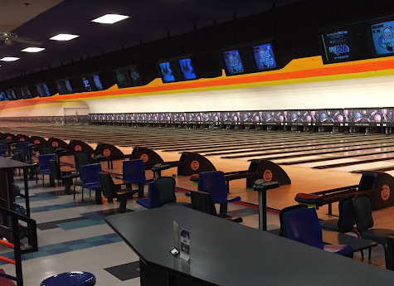
Located inside the Grand Sierra Resort & Casino,
2500 E 2nd St, Reno, NV 89595

COST $16 Per person per hour.
OR
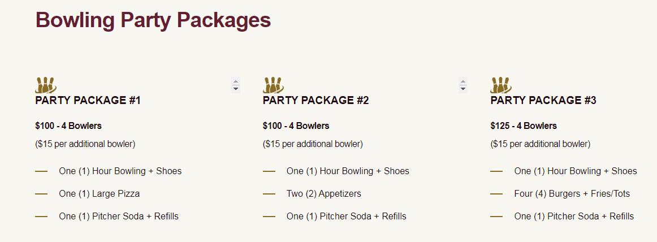

TRIP TO LAKE TAHOE – NEVADA BEACH OPTION
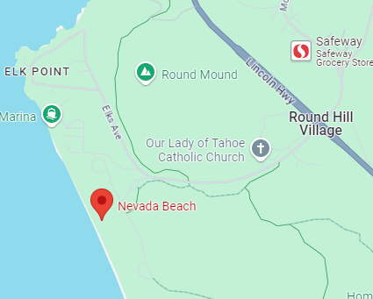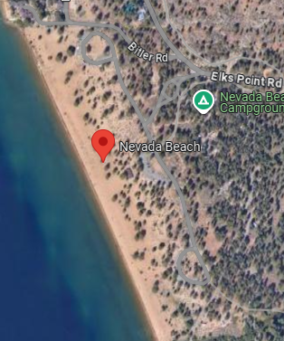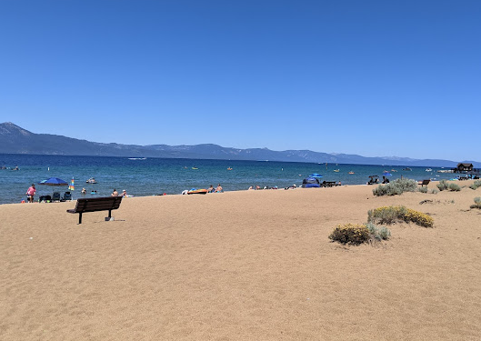

This outing had a few options. Sand Harbor, Dixie Cruise or Nevada Beach.
In my opinion Sand Harbor could be problematic because of the new reservation system. The boat tour was pricey for two hours ($99) and getting tickets on line
could be difficult to coordinate. So I chose to plan a trip to Nevada Beach.
They seem to have ample parking and have restroom services. Looks like an easy walk to beach. I would suggest that we car pool. There is a parking entrance fee.

BOCCE BALL
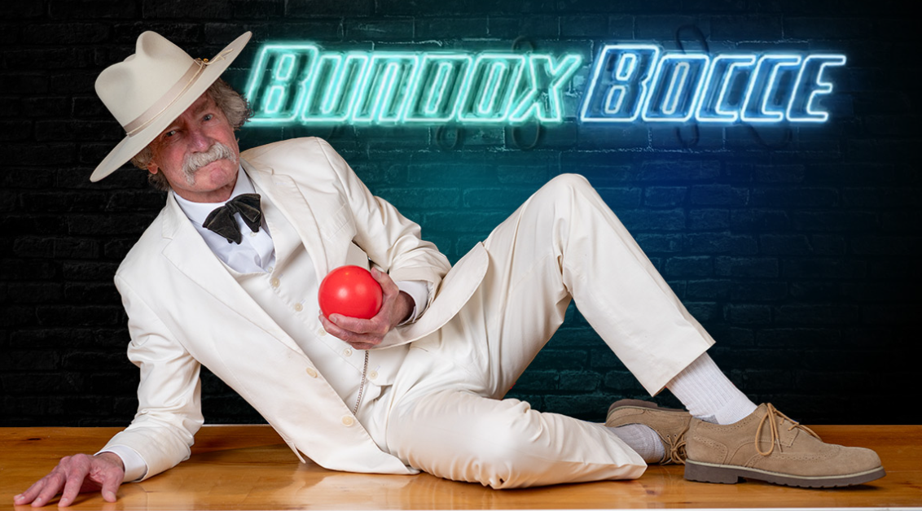
Renaissance Reno Downtown Hotel & Spa
One Lake St, Reno, NV 89501

The court Cost $30 for 50 minutes of play.
They also have full bar and food.

